JET PROPULSION

- TOPICS:

- What is jet propulsion?
- Principle of jet propulsion.
- Classification of propulsive engines.
- Basic theory of operation of rocket engines.

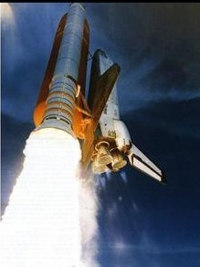

What is jet propulsion?

  - Propulsion of a body by the discharge of fluid is termed as jet propulsion. Jet engine is used to propel the body such as rocket, ship etc.

Principle of jet propulsion:

- The propulsive devices are based on the to fundamental
laws, namely, Newton's second and third law of motion.

- A jet propulsion engine is a reaction engine that discharge a fast moving jet of fluid to generate thrust in the opposite direction of the jet to propel the air craft.

- Thrust force that moves body forward by using propulsive
devices.

- In a jet propulsion engine the propulsive power is not produced by the gas turbine, but its drives the compressor and auxiliary equipment.

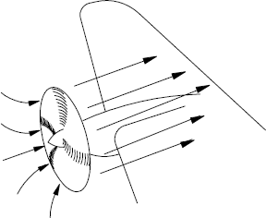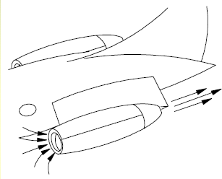

Propeller gives a smaller acceleration to a large weight of air.
Jet engines gives a larger acceleration to a
smaller weight of air.

Classification of propulsive engines

Non Air breathing jet engine (Rocket)

Air breathing jet engine
Propulsive engine
Uses its own propulsive agent (liquid/solid)
Capable to operate beyond earth’s
atmosphere.
e.g., Rocket engines
Uses the atmospheric air as the main fluid. operation is limited within earth’s atmosphere.
e.g., Aircraft engines.

Air breathing jet engine (ABE)

Air breathing jet engine (ABE)

I.C. engine driven
propulsive system

Ramming effect
propulsive system
Gas turbine propulsive system

Turbojet engine

Ramjet engine Pulsejet engine

Turbojet with afterburner

turboprop

Turbofan

I.C. engine propulsive system:
- It is air breathing engine , the which engine take air as working fluid. The net power produced by engine is used to drive the propeller which create thrust as fig.
- The I.C.engine used in this system in an air cooled, multi-cylinder and radial engine with this engine aircraft can be used for short range flight with speed limit of 700km/hr.
- It is widely used to power propulsion of helicopters.

- It is widely used to power propulsion of helicopters.

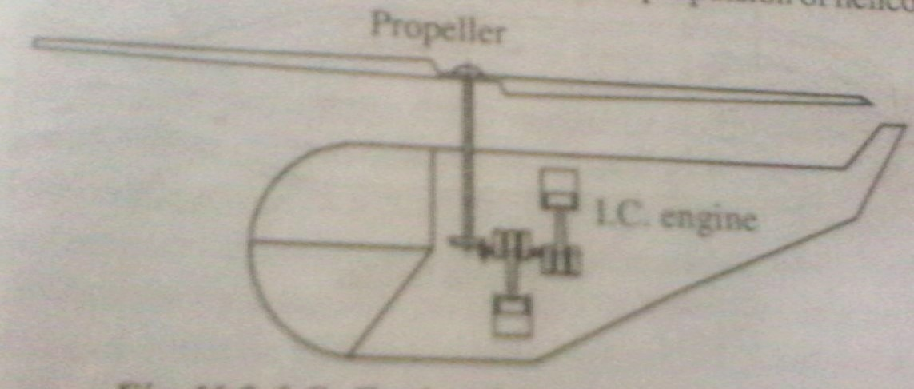

Ram jet

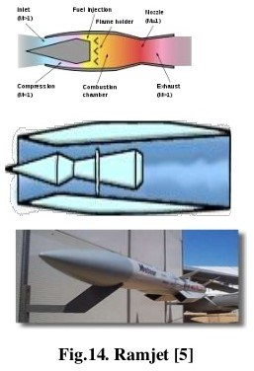
  - Ram jet is air breathing steady combustion or continuous flow engine.
  - Ramjet is simplest of all breathing engines & consists of supersonic & subsonic diffusers , a combustion chamber with fuel injector & a discharge nozzle.
  - It has no moving parts.
  - Combustion occurs at subsonic
speed of airflow.
  - Guided-missile systems , in defense sector used this type of jet.

Advantages :
- Ramjet is the simple in construction and does not have moving part such as compressor and turbine.
- It is very cheap and require almost no
maintenance.
- Greater thrust per unit engine weight than any other propulsion engine at supersonic speed except rocket.
- At very high speed and high altitude the specific fuel consumption is less than turbojet engine.
- It can be operated with any type of liquid fuels
and even with solid nuclear fuels.

Disadvantages :
- At low and moderate speeds , the fuel
consumption is very high.
- It can not be started on it own. it has to be accelerated to a certain flight velocity by some launching device.
- Due to high air speed the combustion chamber requires flame holder to stabilize the combustion.

Pulse jet engine
- A pulse jet is an engine that works on combustion in phases called pulse.
- These engines are usually made using no moving pats.
- Pulse jet diagram: first part of the cycle :air flows through the intake (1),and mixed with fuel (2). Second part : the valve (3) is closed and the ignited fuel-air mix (4) propels .
- Low fuel economy ,however , cheap and easy to build

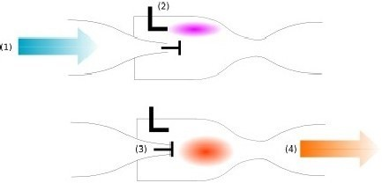

Advantages
  - It is simple in construction compared to turbojet
engine.
  - It does not having moving parts such as compressor,, turbine and propeller .hence it is light , and can carry high pay load.
  - It can be produced sufficient thrust at low speeds.
  - It is highly suitable for bombers and target
missiles because it can be operated without pilot.

DISADVANTAGES
  - It produces very high noise and serve vibrations
due to intermittent pulse.
  - It has high fuel consumption and very low thermal efficiency.
  - It is useful only for short fright life of 30 to 60 minutes.
  - It is affected by atmospheric air density and
hence ,limited operating altitude.

TURBOJET

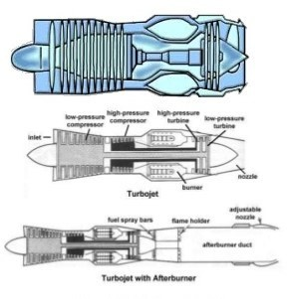
- Turbojet engine is air breathing and gas turbine propulsive system. It is propelled by the thrust produced due to acceleration of the hot combustion gases (coming from the gas turbines) through the exhaust nozzle.
- The turbojet engine is a reaction
engine.
- Substantial increases in thrust can be obtained by employing an after burner.

ADVANTAGES
  - It is simple in construction as compared to I.C.engine propelled system for same power output.
  - The weight power ratio of turbojet engine is one
fourth that of I.C.engine propelled system.
  - The speed of turbojet is not limited by the propeller and it can attain higher flight speeds than I.C.engine propeller aircrafts.
  - The thrust or power output of turbojet is not limited.
  - Less maintenance is required.

Disadvantages:
  - The fuel economy t low flight speeds is extremely
poor.
  - Propulsive efficiently and thrust are lower at low speed . It becomes inefficient below a speed of 550k/hr.
  - Turbojet is not economical for short distance flights. Also it requires longer runway for it take off and landing.
  - High capital cost.

TURBOPROP

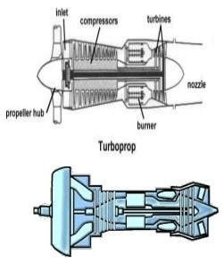
    - A higher thrust per unit mass flow of fuel can be obtained by increasing the mass flow of air and that this result in better fuel economy. this fact is utilized in turboprop engine which is intermediate device between a jet engine and propeller driven by I.C.engine. A turboprop engine is called propjet.
    - A turboprop engine is a jet engine attached to a propeller.
    - Modern turboprop engines are equipped with propellers that have a smaller diameter but larger no. of blades for efficient operation at much higher flight speeds.

Advantages
  - The operation range of turboprop engine is between that of turbojet and propeller engine as it can operate at any speed up to 800 km/hr.
  - It develop higher thrust at low speed and hence take off rolling in short, requiring shorter runway. It is very useful for short rang flight with a speed of 600 km/hr.
  - Thrust reversal is easily achieved by varying the blade angle, and air craft speed can be drastically decresed.

Disadvantages:
  - At high speed, the propulsive efficiency decrease drastically,therby, putting up a maximum speed limit on the engine.
  - It is used only for short range of flight, low
altitude and low speeds.
  - It is requires reduction gear which increase the cost and weight of air craft.

Turbofan

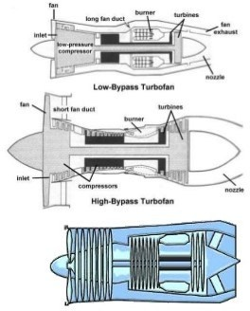
    - The objective of this sort of bypass system is to increase thrust without increasing fuel consumption.
    - It achieves this by increasing the total air-mass flow and reducing the velocity within the same total energy supply.

Non air breathing jet engine (rocket):if the propulsion unit contains its own oxygen supply for combustion purpose , the system is known as rocket engine or rocket propulsion.

Liquid propellant rocket
Solid propellant rocket
Non air breathing jet engine (Rocket)

Solid propellant engine

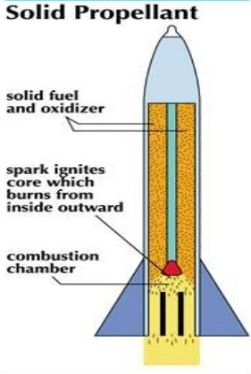
- In a solid propellant rocket system the fuel and oxidizer are mixed together from the start.

- The rocket case is the combustion chamber & holds the propellants. There are no valves, pumps, or sensors.

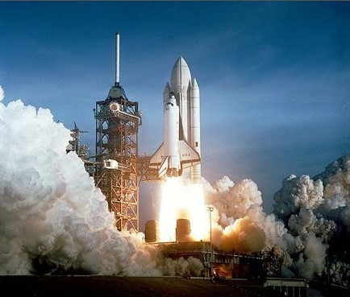
Additives, if needed to increase temperature or
TO CONTROL BURNING, ARE SIMPLY MIXED
WITH PROPELLANT
GRAINS.

THE EARLIEST
ROCKETS WERE SOLID-FUEL ROCKETS POWERED BY
GUNPOWDER.

Liquid propellant rocket
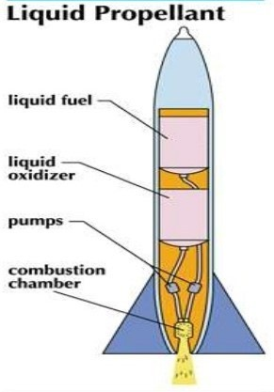
  - In the liquid rocket propellant type rocket engine, fuel tank contains alcohol and oxidizer tank contains liquid oxygen.

  - In the combustion chamber, the fuel and oxidizer burn by electric means which produces high pressure combustion gases.

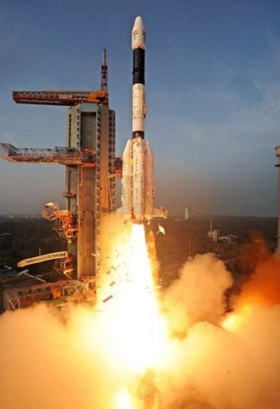

- The combustion gases than passes through the convergent-divergent nozzle in which pressure energy is converted into kinetic energy.

- These high velocity gases going out of the nozzle produce the thrust and propel the rocket.

Basic theory of operation of rocket engine:

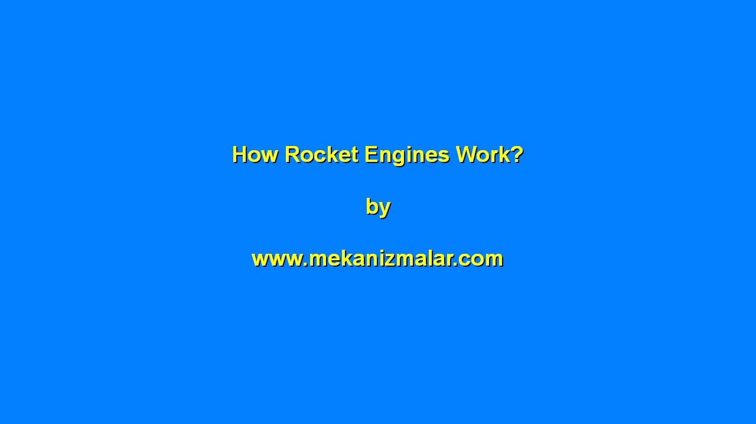

Rocket engine:
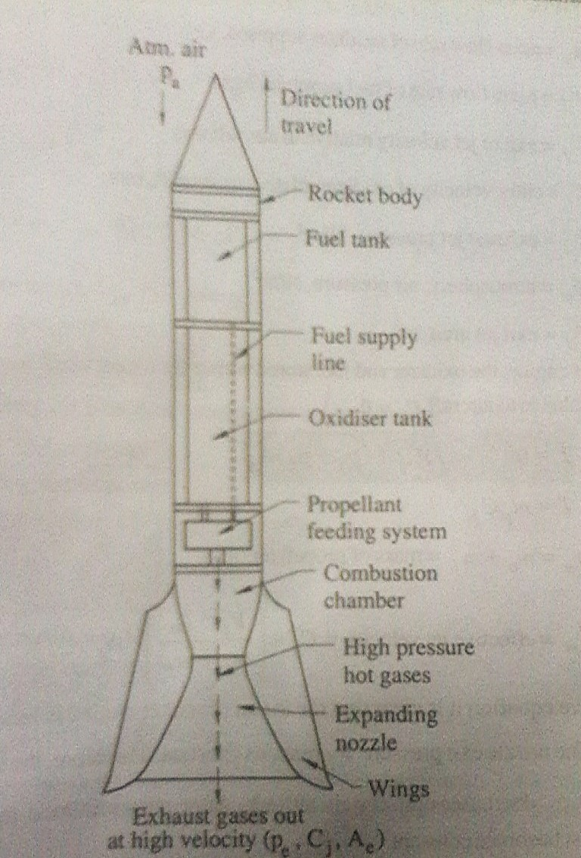

    - Thrust ;the thrust developed in a rocket engine is sum of thrust produced due to momentum (kinetic energy) of exhaust gases and thrust produced due to pressure difference between atmospheric air and exhaust.

Thrust =[momentum thrust]+[pressure thrust]

=

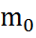
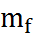
Where, = mass flow rate of oxidizer supplied ,kg/s
=mass flow rate of fuel supplied, kg/s
=exit or jet velocity relative to aircraft, m/s
=entry velocity of oxidizer relative to aircraft,
m/s
=exhaust jet pressure,
=atmospheric air pressure,
=exist jet area
For rocket engine, the oxidizer and fuel stored within the rocket itself, hence entry velocity of oxidizer relative to aircraft = 0

T=


Where, = + = mass propellant

= effective jet velocity = 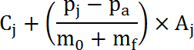
Thrust power: the power developed from thrust of the engine is called thrust power.

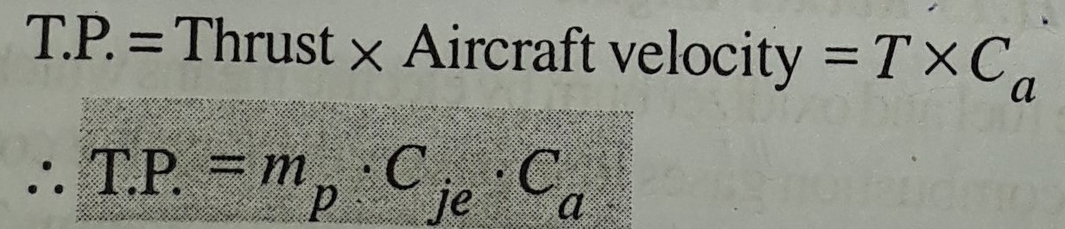

- Specific impulse : it is the ratio of thrust developed to weight of propellant which passes through the rocket engine.
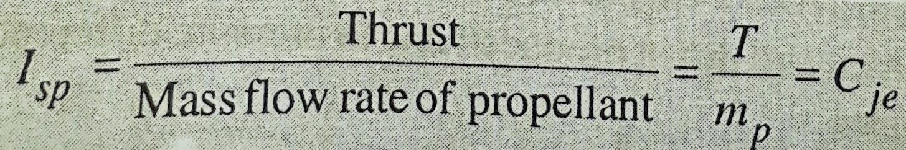

- Propulsive power:
propulsive power =thrust power +power loss in exhaust
=TP+K.E. loss
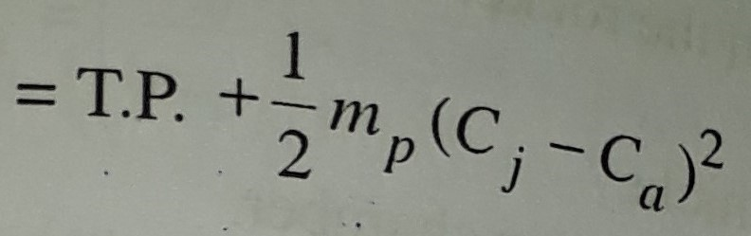

  - Propulsive efficiency : It is ratio of thrust power to propulsive power.

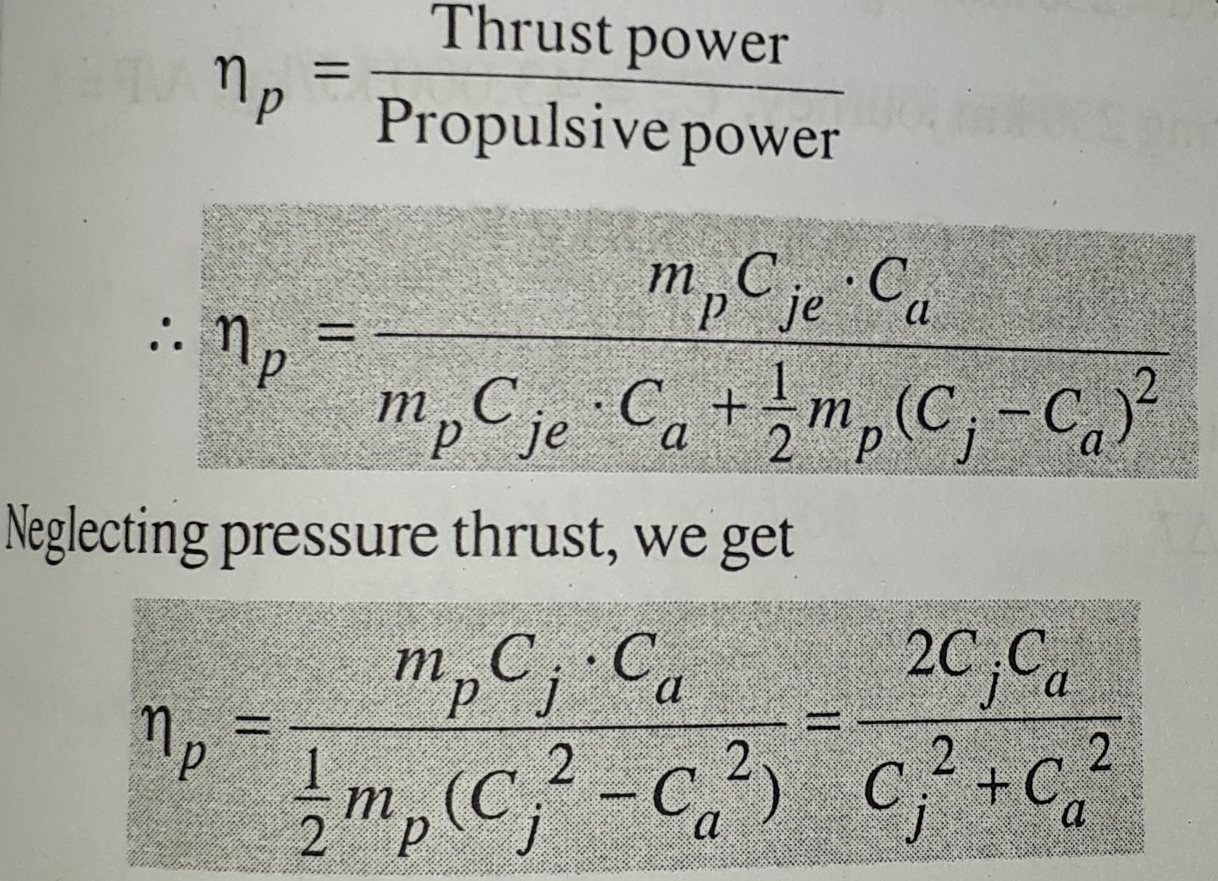

ADVANTAGES
- It is self contained, and non-air-breathing engine, hence it does not depend on atmospheric air condition.
- The thrust produced by rocket engine is increased with altitude and after certain altitude it certain altitude it remains constant.
- Rocket are highly efficient at very high speed (about mach no.>5)
- Rocket engine develops high thrust per unit area. thrust to weight ratio is over 100.
- Rocket can be operate in vacuum.

DISADVANTAGES
- It require large amount of propellant (fuel and
oxidizer)and has very low specific impulse.
- The oxidizer and fuel tank are within the rocket body, makes rocket a very risky vehicle.
- Rocket are extremely noisy space vehicle.
- It offers extreme thermal stresses of combustion chamber.



